**Dictionary Quiz Review Name:**

**Question 1: Review the exercise and code below.**

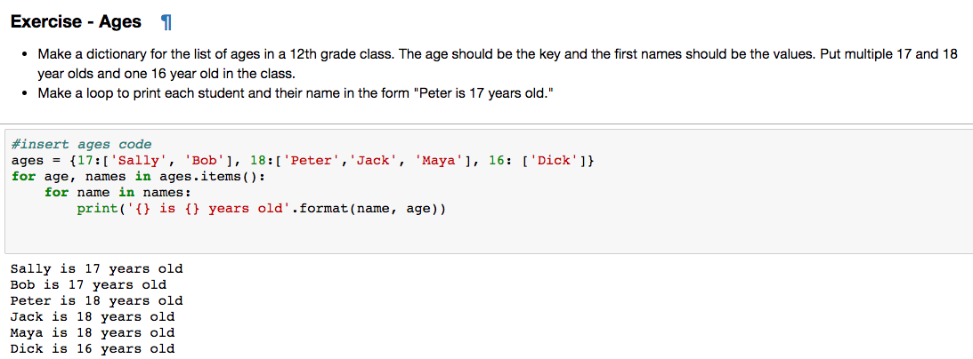

**a. Why are the brackets needed around the single student Dick?**

**b. Why is a nested for loop needed?**

**---------------------------------------------------------------------------------------------------------------------**

**Question 2: Review the exercise and code below.**

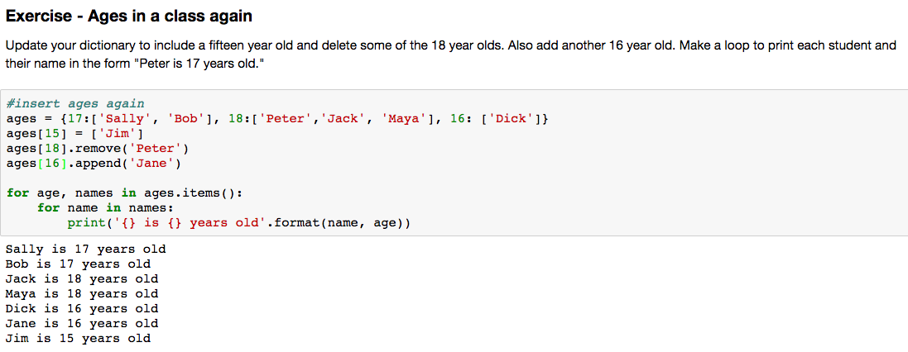

**a. What happened to Jim?**

**b. What happened to Peter?**

**c. What happened to Jane?**

**d. What would happen if instead of typing ages[16].append(‘Jane’) we had typed**

**ages[16] = ‘Jane’?**

**Question 3: Review the exercise and code below.**

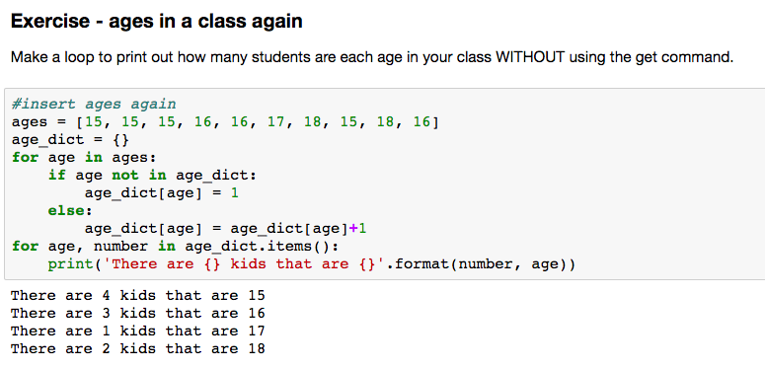

**Explain carefully why the if-else statement is needed above.**

**---------------------------------------------------------------------------------------------------------------------**

**Question 4: Review the exercise and code below.**

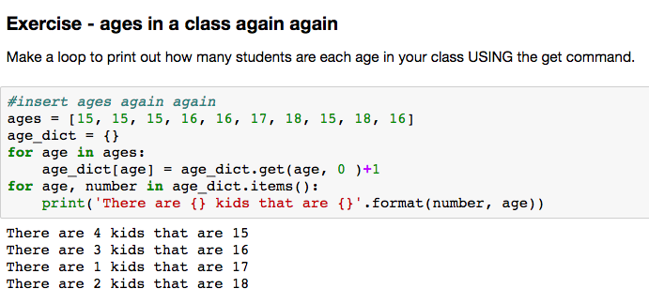

**Explain carefully how the get command in Exercise 4 simplifies the code in Exercise 3.**

**Question 5: Review the exercise and code below.**

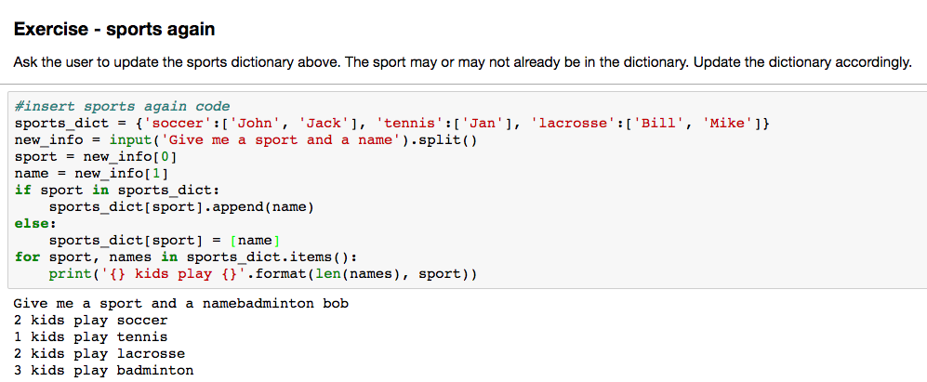

**a. Explain carefully why the if else statement is needed.**

**b. If the user enters that another student likes soccer, which is already in the dictionary, what will happen? What if the new student likes badminton, which is not already in the dictionary?**

**c. Why are the brackets necessary around “name”?**

**Question 6: Review the exercise and code below.**

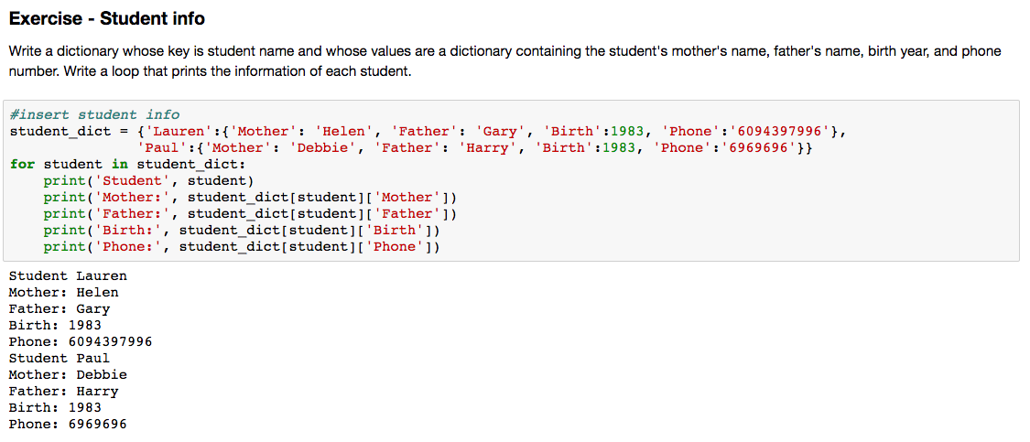

**a. Inside the for loop, what does “student” represent?**

**b. What does “student_dict[student]” represent?**

**c. What does “student_dict[student][‘Mother]”**